# Chapter 2: Review of the Literature on the Topic

## 2.1 Shelters

Animal shelters are organisations that receive homeless and unwanted animals, as well as some animals that have been victims of cruelty. Each shelter has its own guidelines, adoption rules, area of focus and services provided, but the general rule for any animal shelter is that they will treat each animal the better they can, calm them down, give them love and support, and help them to find their forever home (peta.org).

Shelters can be public or private-owned, where the former may, or may not receive governmental allowance, and the latter, usually referred to as a rescue centre, is owned by a private organisation and/or supported by private investors (Cyrenne, 2019). Ireland currently has many animal shelters around the country, and a table with information provided by the website *Rescue Animals Ireland* categorises 129 organisations within their county (please, see *Appendix A4*). Many of the organisations listed in this website do not disclose their foundation date, it is possible to infer that the oldest ones date from the mid-end of the 19th century, such as the *Dublin Society for Prevention of Cruelty to Animals* (DSPCA), being founded in 1840, followed by the *Cork Society for Prevention of Cruelty to Animals* (CSPCA) in 1870, *Kilkenny Society for Prevention of Cruelty to Animals* (KSPCA) in 1882, *Wexford Society for Prevention of Cruelty to Animals* (WSPCA) in 1888 and *Wicklow Society for Prevention of Cruelty to Animals* (Wicklow SPCA) in 1910. Over the last 20 years, 45 organisations among those provided by the *Rescue Animals Ireland* website have been founded, of which 18 only during the last 10 years (Rescue Animals Ireland, 2020a).

In addition to the shelters and rescue centres, animals can also be retained in pounds, which are Council facilities that shelter an animal that was found wandering, or even captured by wardens, or abandoned by the public (Pet Rescue, 2019). Besides the reasons already mentioned, there are many more for dogs, ending up in pounds. In Ireland, by law, a dog can only be retained in a pound up to five days and if a dog is not reclaimed, rehomed or adopted within this period, it may be destroyed (Dundalk Dog Rescue, 2020). In pounds, if an unwanted dog is given by its owner, the pound may sell it, give it away or destroy it in a humane manner (Control of Dogs Act, 1986).

## 2.2 History of Animal Adoption and Data Privacy Laws in Ireland

Laws, regarding animal protection in Ireland, have been improved and amended over the years, since they were first created between the second half of the 19th century and the beginning of the 20th century with the *Control of Dogs Act* and *Protection of Animals Act*, when Ireland was still under the British government. In 1935, the *Pounds Provision and Maintenance Act* was created, which describes the duty of the local authorities to provide pounds, the control and cease of use of pounds, about their repair and regulations (Pounds Provision and Maintenance Act, 1935). In 1965 an amendment of the *Protection of Animals Act* was released, in which they talk about animal abandonment, animal rights when being kept in pounds, penalties for anyone that commits animal cruelty, and more (Protection of Animals Amendment Act, 1965).

The Animals Act of 1985 came to amend the Law, relating to liability for damage done by animals and the Law, relating to the impounding of animals. In 1986, the Irish Government released their own specific Law, regarding dogs, also called *Control of Dogs Act*, where the prohibition on keeping a dog without a license and exemptions, as well as the duration and fees, were explained. This Act also deals with the owner responsibilities when in charge of a dog, the seizure of stray dogs, the receival of unwanted dogs by a Local authority, the register of seized dogs, the duties of the Local authorities, the impose of control of a dog, or its destruction, offences and penalties, and more (Control of Dogs Act, 1986). Furthermore, the Minister of State at the Department of Rural and Community Development stated that the Control of Dogs Acts, 1986 to 2010, aim to provide arrangements focused on the protection of the society, while complying with the dog owners’ rights, in a fair and feasible manner. This law set additional requirements, regarding owners of 10 specific breeds (Canney, 2019).

Based on several previously established laws, among of which we can cite the Control of Dogs Act, the Control of Horses Act, Diseases of Animals Act and Protection of Animals Act, the Animal Health and Welfare Act was created in 2013, even though it only came into play in 2014. This Act was established in order to revise the law relating to the health and welfare of animals, their protection and identification, as well as to provide regulations, to prevent cruelty, but not restricted to those (Animal Health and Welfare Act, 2013). Amendments to all the laws previously mentioned, have been made over the years, however they will not be all presented in this research document.

Despite all regulations, regarding animals in Ireland, there is no specific law, involving the steps to follow when initiating any pet adoption process. Nonetheless, there are some common steps that potential adopters must follow in most shelters during the adoption process, such as visiting the shelter to see all pets available for adoption, talking to one of the consultants/shelter workers about a pet they are interested in, and filling an application form. Not only that, a dog meeting may be required in order to check the compatibility of any existing dog, the person may have, with the one that is under the adoption process, and a home check is usually carried out to guarantee that the house is suitable for the pet. The steps may also vary, depending on the species of pets the person is interested in: for a cat, for example, the adoption process can be much simpler, by just visiting the shelter, talking to a consultant/shelter worker and filling up the adoption form (The Dublin Society for Prevention of Cruelty in Animals – DSPCA, 2020). Even though shelters and rescuers are usually non-profitable, they may charge the adopter a fee as a donation, in order to help with their expenses, regarding all the services provided, like kennelling, food, vet bills, spay/neuter, microchipping, vaccination and deworming (Rescue Animals Ireland, 2020b). Yet, in case of dog adoptions, there are still a number of legal requirements that pet owners must obey after having adopted them, such as acquiring a dog license when the dog is over 4 months of age, microchipping and registering their dog on an authorised database up to the age of 12 weeks (if they are not already microchipped and registered), dogs must wear a collar containing their name and owners’ address, specific breeds must be muzzled and kept on a leash at all times, and some more requirements (Citizens Information, 2020).

All these rules raise questions and debates from the public about their data privacy

and how their personal information is being and can be used. In order to protect people’s privacy, data protection laws have been sanctioned and amended over the years. The first specific law in Ireland, regarding data protection was created in 1988, the so called *Data Protection Act*, (1988) to give effect to the Convention for the Protection of Individuals with regard to Automatic Processing of Personal Data, in 1981, where the European Union member States signed a treaty that aimed to provide guarantees in relation to the collection and processing of data (including sensitive data) in the absence of proper legal safeguards (Council of Europe, 1981). The Data Protection Act, written in 1988, among other things, guarantees that the personal data kept within a data controller must be accurate and kept up to date, as well as it should only be kept for specified lawful purposes and not to be used or disclosed in any manner that is incompatible with the purpose(s) it was acquired, also it must not be kept longer than is necessary. All data must be secure in a way that “appropriate security measures shall be taken in case of unauthorised access to, or alteration, disclosure or destruction of, the data and against their accidental loss or destruction” (Data Protection Act, 1988).

Amendments to the Data Protection Act were made in 2003 and 2018, where the latter came into play in order to abide to the new European Union-wide framework, the General Data Protection Regulation (GDPR). This regulation improves the standardisation of interpretation and application of data protection norms across the European Union. In September 2nd 2019, a Revised Act was released, in which all Acts up to and including the Judicial Council Act 2019, in an administrative consolidation of the Data Protection Act 1988 (Citizens Information, 2019).

## 2.3 Mobile Application History

A mobile application, or as commonly referred to in the current days, “mobile app”, is defined as a software program, developed for mobile devices to perform specific tasks (Viswanathan, 2019). The history of mobile apps dates back to 2002, when the first Blackberry Smartphone was launched, however, Apple’s App store went online only in July 2008, releasing about 552 apps, of which just 135 were free to download, followed by the Android market later that year (JetRuby, 2017).

According to JetRuby (2017), 85% of the users in 2017 preferred mobile devices than desktops and an app could be chosen from a list of 5,000,000 applications available on the market, however, with no doubt this number has increased in the past 3 years. Before March 6, 2012, Android users had to download the desired apps in each specific content store, though after that date, all these small stores were consolidated into a single platform, called *Google Play Store* with a total of 450,000 Android apps and games to download, once more, these numbers have obviously increased to over 1.5 million in *Google Play* and over 1.2 million for iOS users in the *Apple App Store* nowadays (Callaham, 2017).

## 2.4 IoT History

Looking into the past of Internet of Things (IoT), it started in 1982 with the creation of the Internet with the TCP/IP protocol. Subsequently, the first connected device was created in 1990, which was a toaster, created by Simon Hackett and powered through the Internet; the term “Internet of Things” came up 17 years later, in 1999, by Kevin Ashton who established a global research network, focused on Radio Frequency Identification (RFID) and the IoT; at the same year, the MQ Telemetry Transport (MQTT) protocol was introduced by Andy Stanford-Clark of *IBM* and Arlen Nipper of *Eurotech* (former *Arcom*). This protocol presented the first machine-to-machine protocol for connected devices. A year later, the first connected refrigerator plan was launched by *LG* - the idea suggested that the device would sense items stored inside by scanning barcodes and RFID’s (Romkey, et al., 2014).

According to Romkey, et al. (2014), in 2005, the IoT became globally known for being mentioned by the United Nations in an International Telecommunications Union report, and three years later the first international IoT conference happened in Zurich. Still in 2005, a WiFi enabled rabbit was able to alert and speak about stock market reports, news headlines, alarm clocks, RSS-Feeds, etc. (Hardwood, 2019). *Arduino* and *Raspberry Pi*, which are great tools to be used in IoT, had their first prototypes created in 2005 and 2006, respectively. (The history of *Raspberry Pi* will be discussed in Section 2.5 of this document).

After that, year 2008 was marked with the promotion of IP connections between networks of “smart objects” by *IPSO Alliance*. By 2009 there were more things or objects connected to the Internet than people, which means that by 2010 the number of devices connected to the Internet was brought to 12.5 billion (Hardwood, 2019). Still in 2010, there was a significant progress was made by *Google*, which introduced a *self-driving vehicle* project, and in the same year Bluetooth Low Energy (BLE) was introduced, enabling more applications in different industries, such as fitness, health care, security and more home entertainment.

Figure 2.1 shows the progression of number of devices connected over Internet according to the population of the world in the period 2003 – 2010, which denotes drastic change from 0.08 devices/person in 2003 to 1.84 devices per person; it also shows a prediction for the following 5-years period (2015 – 2020). Although these numbers are taking into consideration the entire world population, according to Evans (2011), if we look only into people who actually had access to the Internet by 2010, which was approximately 2 billion people, the progression of the number of connected devices per person would be showing an increase to 6.25 devices connected per person by year 2020.

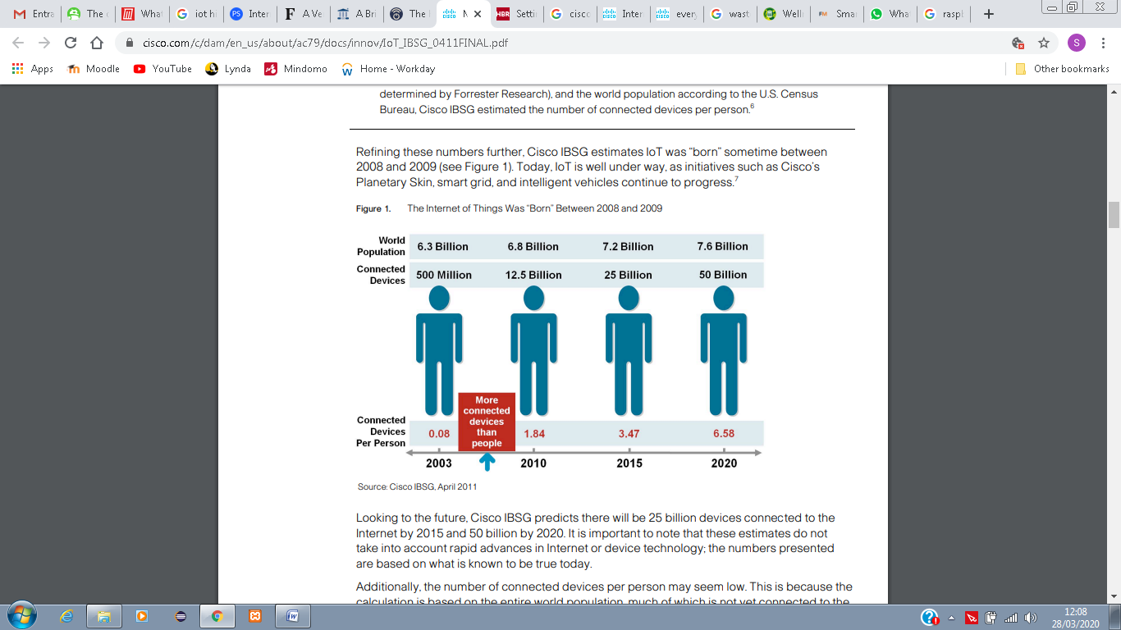

Figure 2.1: IoT progression numbers (Evans, 2011).

The following year, *Google* started *Nest*, by use of sensors, WiFi, programmable thermostats and smoke detectors. Also, due to the large amount of users and devices connected to the Internet, the number of IPs (unique identifier of a device) were reaching an end, thus the creation of a new type of IP was made necessary, creating the IPv6 type, which allowed the identification of over 340 undecillion new IP addresses to be assigned to devices. In 2013, *voice recognition* software came in handy in order to control the new IoT device, *Google Glass*, which was released to developers with a built-in touchpad. The year 2014 brought up geo-location services, advanced by the firm *iBeacon*, and *Apple* announced two health and home automation developments.

Subsequently, in 2014/2015, the IoT became real and reached its mass market with data from *General Electric*, who announced the generation of $1 billion revenue of IoT-related projects, and *Google* also announced to buy *Nest* for $3.2 billion.

Back to the prediction, made by Evans in 2011 for the years to come, we can see that these numbers have been outdated. Evans himself has lowered his expectations by saying “*I think people do tend to latch onto numbers that seem really hard to fathom. Fifty billion is pretty staggering*”. The following predictions seem to be more accurate, even though has been hard to prove, since there are a lot of different concepts regarding IoT and what does it involve.

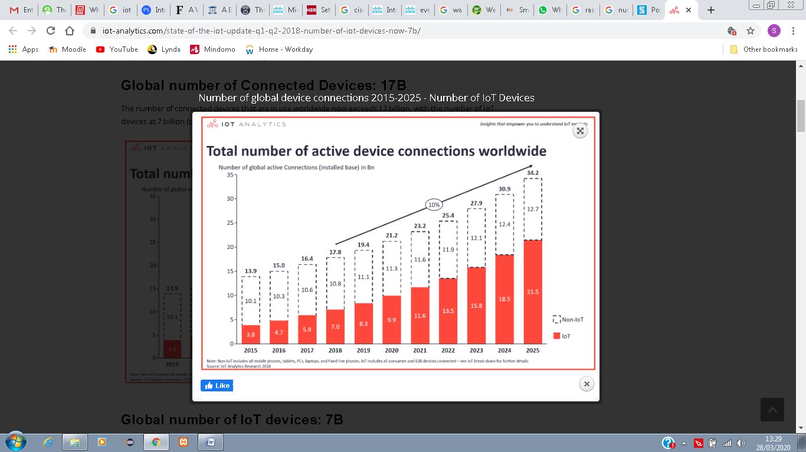

Figure 2.2: Total number of active device connections worldwide (Lueth, 2018).

As presented on Figure 2.2, Lueth (2018) showed a number, closer to the reality, and the different numbers between IoT devices and regular devices, such as Smartphones, laptops, PC’s, etc. Thus, by 2015, there were a total number of 13.9 billion devices connected, of which only 3.8 billion were considered to be IoT devices, and a projection of 21.2 billion of devices connected to Internet by 2020, of which 9.9 billion would be IoT devices. This year’s numbers are still to be confirmed in the coming years, but since there were 16.4 billion of devices in 2017, it seems we are in the right path to achieve the prediction goals.

The years that followed 2014 brought up a lot of improvements in terms of the use of IoT technology in real life devices, in order to create efficiency for users. A few examples will be mentioned in Section 2.6 of this document.

## 2.5 Raspberry Pi

One important description to be made, that has not yet been clarified in the current document, is how *IoT* and *Raspberry Pi* connect with each other. In order to answer this question, we must first describe the concept of IoT, which involves the collection of data, using sensor(s), the processing of the collected data, and the ability to act on the collected data, according to a criteria (for example, if a doorbell senses that there is someone nearby the house, it would alert the house owner and an action can be made upon the information).

*Raspberry Pi,* as well as *Arduino*, is used in IoT with the goal to provide the hardware that will do these actions (collect, process, act), since they are a small, inexpensive electronic board credit card-sized computer, that allows the connection of external accessories, such as sensors. Raspbian Operating System (based on Debian Operating System (OS)), is the most popular OS used for *Raspberry Pi,* and *Python* is the language, used for coding it (Lee & Chang, 2018).

The history of *Raspberry Pi* dates back at 2006, with Eben Upton, at time we were at the beginning of the Internet. The name *Raspberry* came from a convention, since most computer manufacturers’ names came from fruits (Apple, Acorns and Apricots) and the *Pi* came as a reference to the *Python* language, used to program these devices. The models and versions of *Raspberry Pi* were released as follows:

* 2012 – Raspberry Pi Version 1 B
* 2013 – Raspberry Pi Version 1 A
* 2014 – Raspberry Pi Version 1 A+
* 2015 – Raspberry Pi Version 2 B
* 2015 – Raspberry Pi Zero
* 2016 – Raspberry Pi Version 2 B ver. 1.2
* 2016 – Raspberry Pi Version 3 B
* 2017 – Raspberry Pi Zero W
* 2018 – Raspberry Pi Version 3 A+
* 2018 – Raspberry Pi Version 3 B+
* 2018 – Raspberry Pi Zero WH

The reason why there is a *Version A* and a *Version B* is because Upton wanted to create a Cheaper model (*A*) and a Faster model (*B*), with the *Zero* model came in handy, since it was also smaller (Fromaget, 2020). Figure 2.3 shows the *Raspberry Pi Zero W* model and its features.

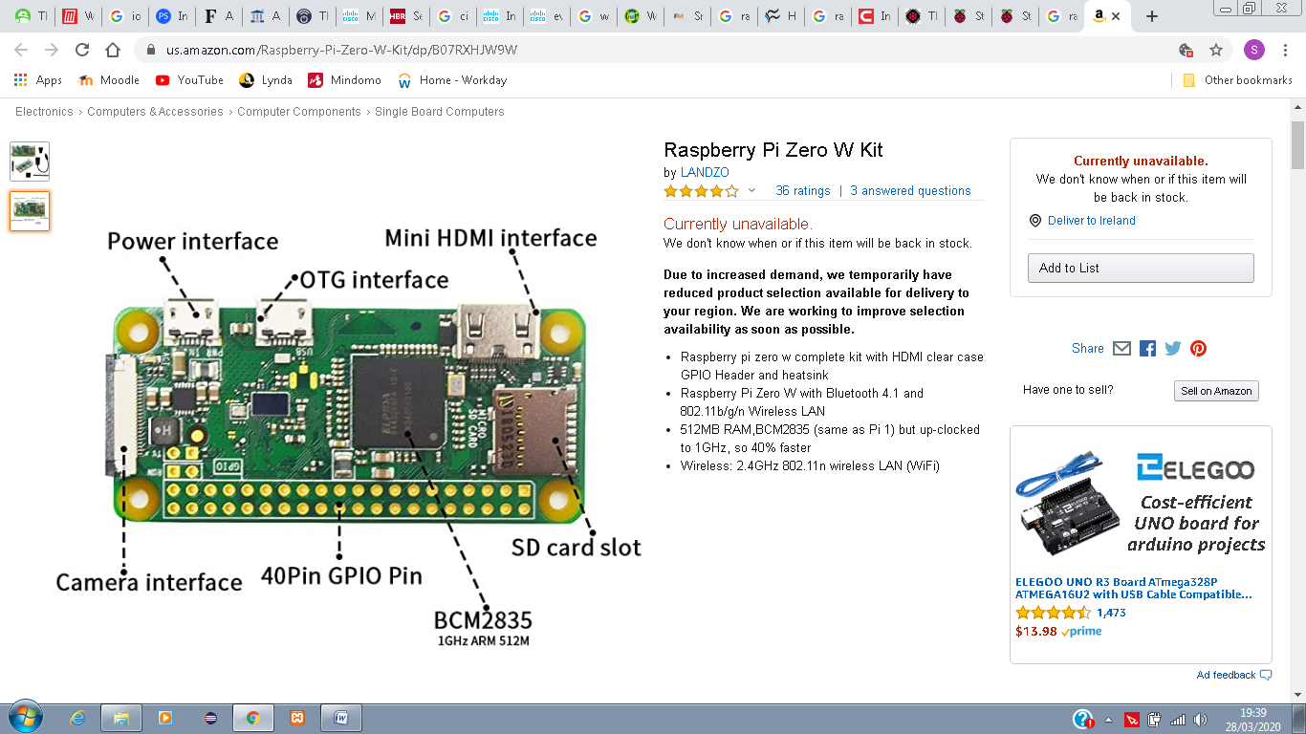

Figure 2.3: Raspberry Pi’s Features (Amazon, 2020).

GPIO or General Purpose Input/Output are very important feature when using Raspberry Pi because they can be designated as an input or output within the software and used for several different purposes. Current Raspberry Pi versions are provided with a 40-pin GPIO header (as show in Figure 2.4) while earlier versions (prior to the Pi 1 Model B+ from 2014) were provided with only a 26-pin header (Raspberry Pi Foundation, 2020).

Other components on the Raspberry Pi board are as follows:

* Arm CPU/GPU
* RCA
* Audio out
* LEDs
* USB
* HDMI
* Power
* SD cardslot
* Ethernet

(Johnson, 2020)

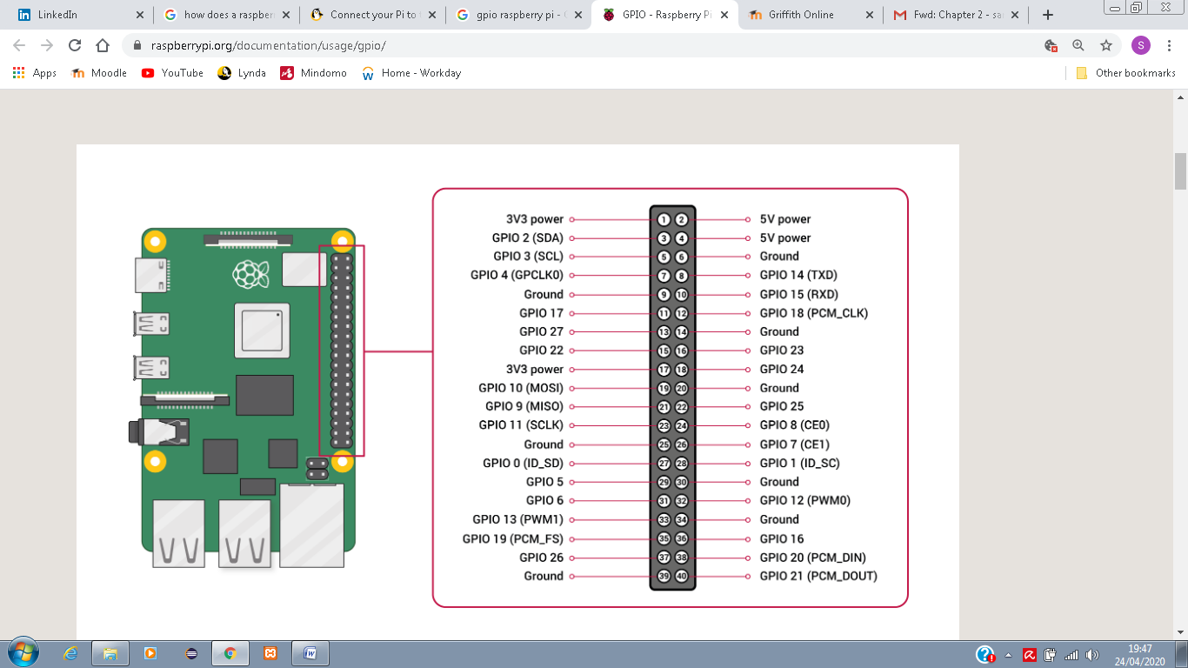

Figure 2.4: Raspberry Pi 40 GPIO pins (Raspberry Pi Foundation, 2020).

After said that, it is no mystery how these devices are connected to the internet. In a wired connection, an Ethernet cable can be used to connect to routers and an IP address is configured to Raspberry Pi via DHCP. However, in modern versions of Raspberry Pi as from version 3, Wi-Fi is built in the device (Dataplicity, 2019).

## 2.6 Uses of IoT in Real Life

After all that has been mentioned, we now have an idea of the magnitude and importance of IoT and it is even more important to show how it was implemented over the years with some real projects.

Most of the projects, using IoT to improve and facilitate the user’s life, are simple devices which are not meant to be “smart”, but now are able to connect to the Internet, pay bills, etc. Some such devices are watches, bulbs, sensors, cameras, etc. These devices have access to technology, such as *Bluetooth*, *NFC*, among others, that allow them to connect to the Internet, collect data, transmit data, analyse data and most importantly - take measures in case needed (Bravo, 2019). With that in mind, the need for creating smart cities and introducing the IoT into the public sector has increased in the past decade. Amsterdam, for example, since 2019 has more than forty streetlights that can be controlled via mobile phones of users, in order to create a more smart, safer, cleaner (energy related) city. The city’s streetlights are equipped with LED technology and the use of solar panels and wind turbines. While citizens can control the lights via mobile phone app while walking, running or cycling, the visibility can be improved creating a safer environment. Once the users have passed the streetlights, the light intensity would automatically drop. This is all possible thanks to the use of movement sensors and traffic density. Accidents and emergencies can be better dealt by Police departments and traffic offices with the use of such devices (Bravo, 2019). The picture presented on Figure 2.4 shows the difference between and the advantages of using smart lightning options over traditional lightning options.

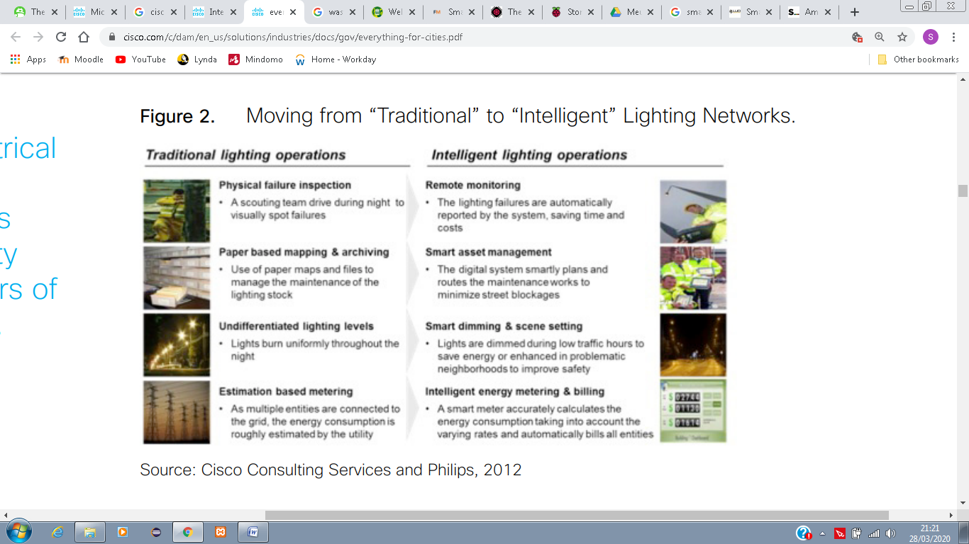

Figure 2.5: Traditional and Intelligent lighting comparison (Mitchel, et al., 2013).

Granada (Spain) has implemented a pioneering project for smart waste collection. The project consists of use of volumetric measurement sensors, installed in reinforced bins, which would inform the collection centre that the bin needs to be emptied soon. By doing so, truck routes became more efficient, it can save millions to the city, and reduction of carbon emitted by the trucks, while stopping at each and every bin, including the empty ones (Horwitz, 2017).

An initiative to save Rhinos, Elephants and other endangered animals, targeted for their body parts in Kenya, have been put in place by the Zoological Society of London in partnership with a grant from *Google*. The project uses camera that looks for wild animals, but most importantly for poachers (Upton, 2013).

A very important IoT device nowadays is the *Smart Home* device, examples of which include *Google Home*, *Amazon Echo* and *Apple HomePod*, each one using its digital assistants, such as Google Assistant for *Google Home*, Alexa for *Amazon Echo* and Apple’s Siri for *Apple HomePod* (Gebhart, 2019). They all have the same abilities, however, use different operating systems. In order to keep it simple, since the current Project intends to use *Google Home* to integrate with the proposed mobile application, we will describe the *Google Home’s* features in this document.

Still, according to Gebhart (2019), *Google Home* is a central hub for connected devices (smart speaker), launched in 2016 and designed to compete with *Amazon’s Echo*, which was launched in 2014 and became very popular by the time. The device always listens to the environment and responds to the user’s commands when the *key words* are spoken, in this case, “*OK, Google*” or “*Hey, Google*”. However, the most interesting thing about *Google Home* is its capability to connect with several different devices, and the ability to control each and every one of them. For example, you can connect *smart bulbs*, *smart fridge*, *smart heaters*, etc., and with that, the user is capable of turning on/off the lights, increase/decrease the temperature in the house’s fridge, turn on/off the heater in the house, etc. Some of the supported devices by *Google Home* are as follows: Nest Thermostats, Philips Hue, Samsung SmartThings, Honeywell, Belkin Wermo, TP-Link, LIFX, Best Buy Insignia, IFTTT, iHome, Emberlight, Leviton, among others (Westernberg, 2019). These are just a few examples of what can be done with the device, but the possibilities are infinite.

## 2.7 Case Studies on IoT Applications

Internet of Things (IoT) devices are becoming more popular over the years, which leads to an increase in number of mobile applications, able to connect and interface with them, the *IoT apps*. These apps are developed with everyday situations in mind, that customers usually face, in a way that it can hugely affect people’s lives (Cherednichenko, 2018). Some examples of such applications are discussed as follows:

* **Nest**

According to Cherednichenko (2018), *Nest* is one of the best examples of an IoT app. Compatible with *smart thermostats*, *home alarm systems*, *doorbells*, *smart cameras* and *smoke alarms*, this app allows the user to control many different types of devices, while away from home. It also has a feature that manages the home automatically when the user set it to the *away* mode, such as tuning everything off or switching the cameras on (please, see Figure 2.5). This app has a rating of 4.3 from all its 110,140 evaluations on *Google Play Store* (Google Play, 2020a).

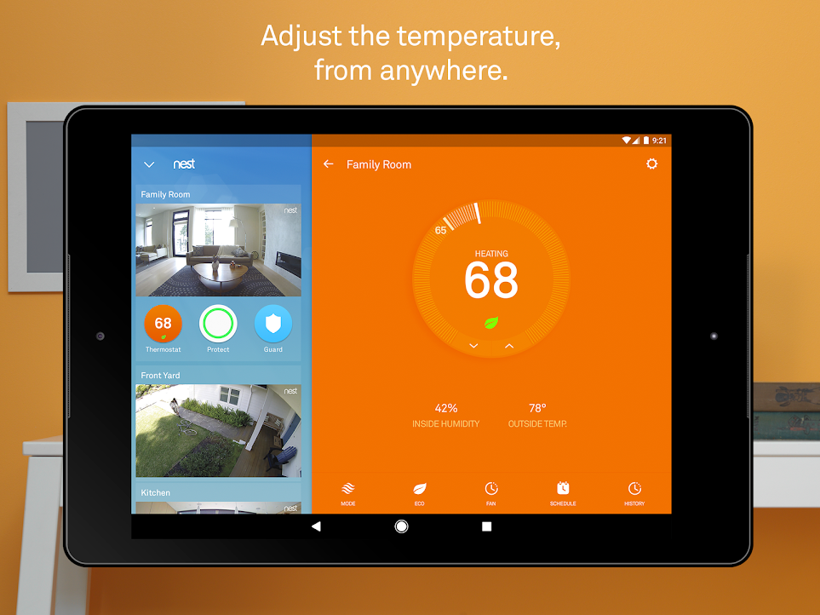

Figure 2.6: Control Screen of the Nest app (Google Play, 2020a).

* **Whistle – Pet Tracker**

Still, according to Cherednichenko (2018), *Whistle – Pet Tracker* is another useful IoT app to give it a go. This app is integrated with *Whistle GPS* tracker device, that can be attached to the pet’s collar. This allows the pet owner to find their dog by showing their exact location, as well as their activity (please, see Figure 2.6). This app has a rating of 3.3 from all its 706 evaluations on Google Play Store (Google Play, 2020b).

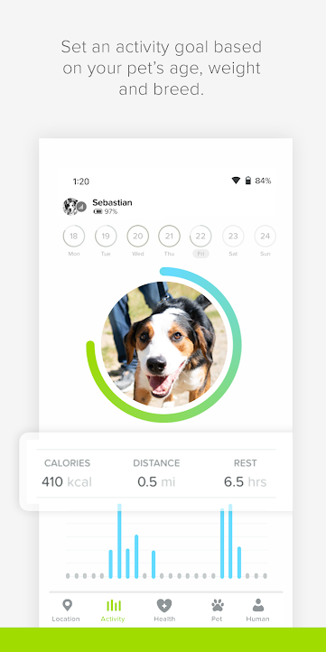

*Figure 2.7: Whistle - Pet Tracker, Activity Screen (Google Play, 2020b).*

* **Smart Life**

*Smart Life* is an IoT app that allows the user to remotely control home devices from anywhere. It can be connected with multiple smart devices and it can automatically start/stop working, according to the users predefined settings, if any, such as according to weather changes, or following a specific schedule (please, see Figure 2.7). This app can be *voice* controlled via *Amazon Echo* and *Google Assistant*. The app has a rating of 3.6 of all its 24,038 evaluations on Google Play Store (Google Play, 2020c).

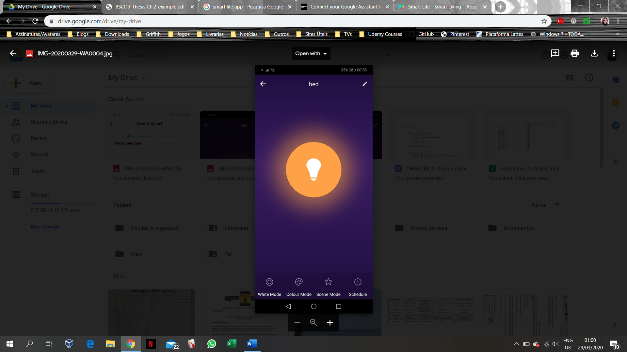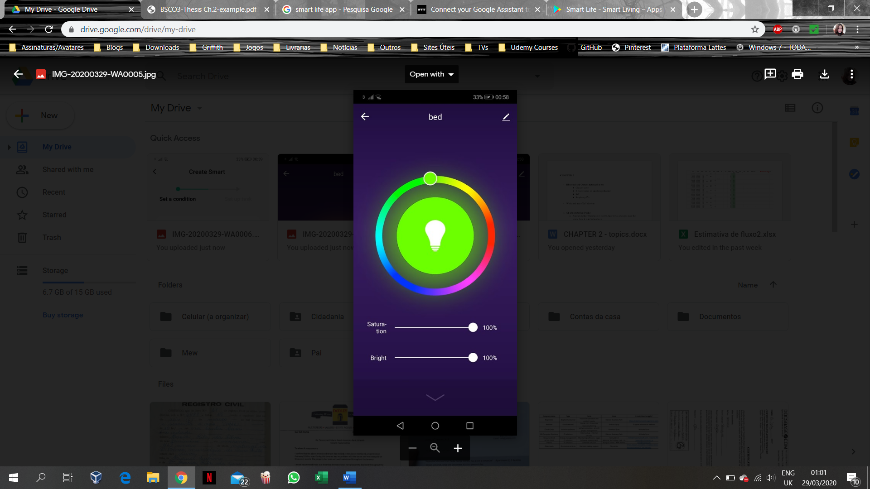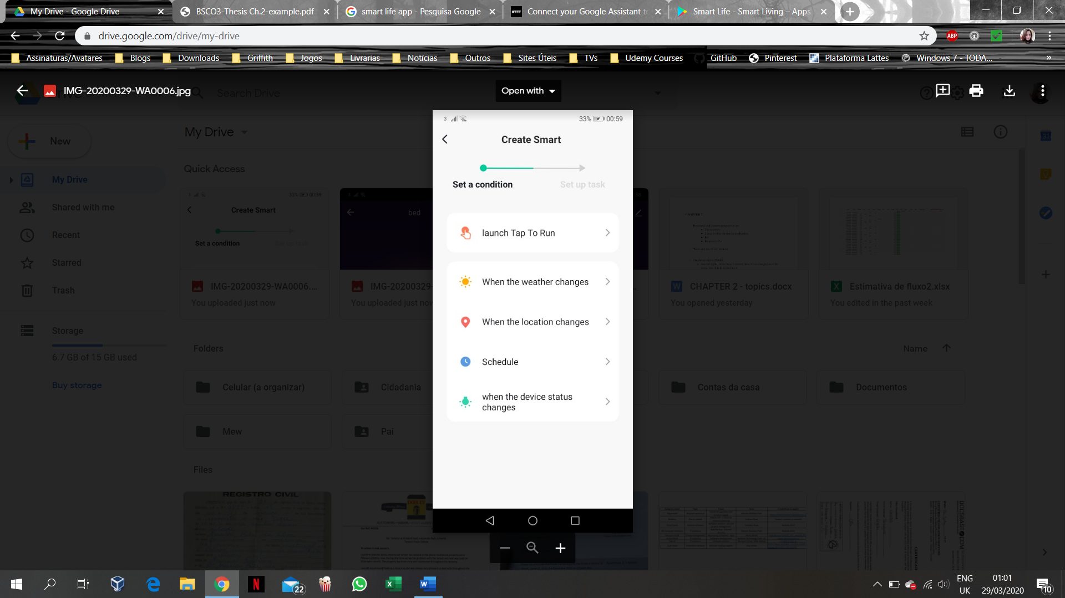

Figure 2.8: Smart Life bulb control and automated control screens (Google Play, 2020c).

## 2.8 Case studies on similar mobile applications

* **Appets**

*Appets* is an app, programmed by the Colombian Jonny Acevedo. In the app, you can browse through a list of pets available for adoption, and each animal can be posted by different entities, whether they are a foundation without a profit, a pet shelter, or a civilian that has puppies to give for adoption (please, see Figure 2.8). The app provides a world-wide range of places to search for a pet, with exceptions. At first, the user is asked to login - the app provides you with options to either *adopt a pet*, *find lost pet*, or *find services* and *help*. The *find a lost pet* option is designated to people who have lost their pets and want to find them by posting information, as well as helping people find their lost pets that have been already found. While browsing an *adopt a pet* option, or *find lost pets,* you can either filter or scroll down through pictures of the pets available. Once the pet is selected, you are directed to a screen in which you find the information of the current owner of the pet, as well as the option to send them a message through the app, however, this message option is not available for all the pets, which means that there is an option for opting messaging out from the owners of the pets. The app has a rating of 3.5 from 37 evaluations on Google Play Store (Google Play, 2020d). However, when using the app to find a pet in Limerick, Ireland, it did not return any results. Thus, the application to be developed in the current Project aims to provide a more local search, which can be applied to any country in the world, amending to its adoption’s parameters, however, intended specifically for Ireland at present. Also, the information provided for each pet would be from registered organizations within the local authorities, which means the information would be more reliable.

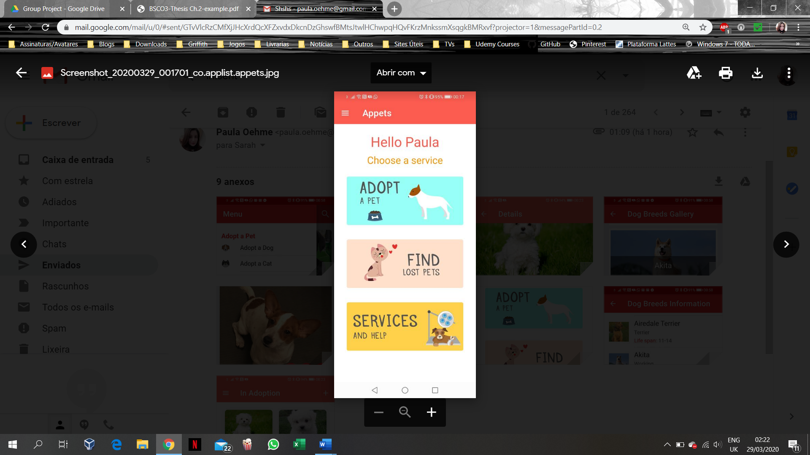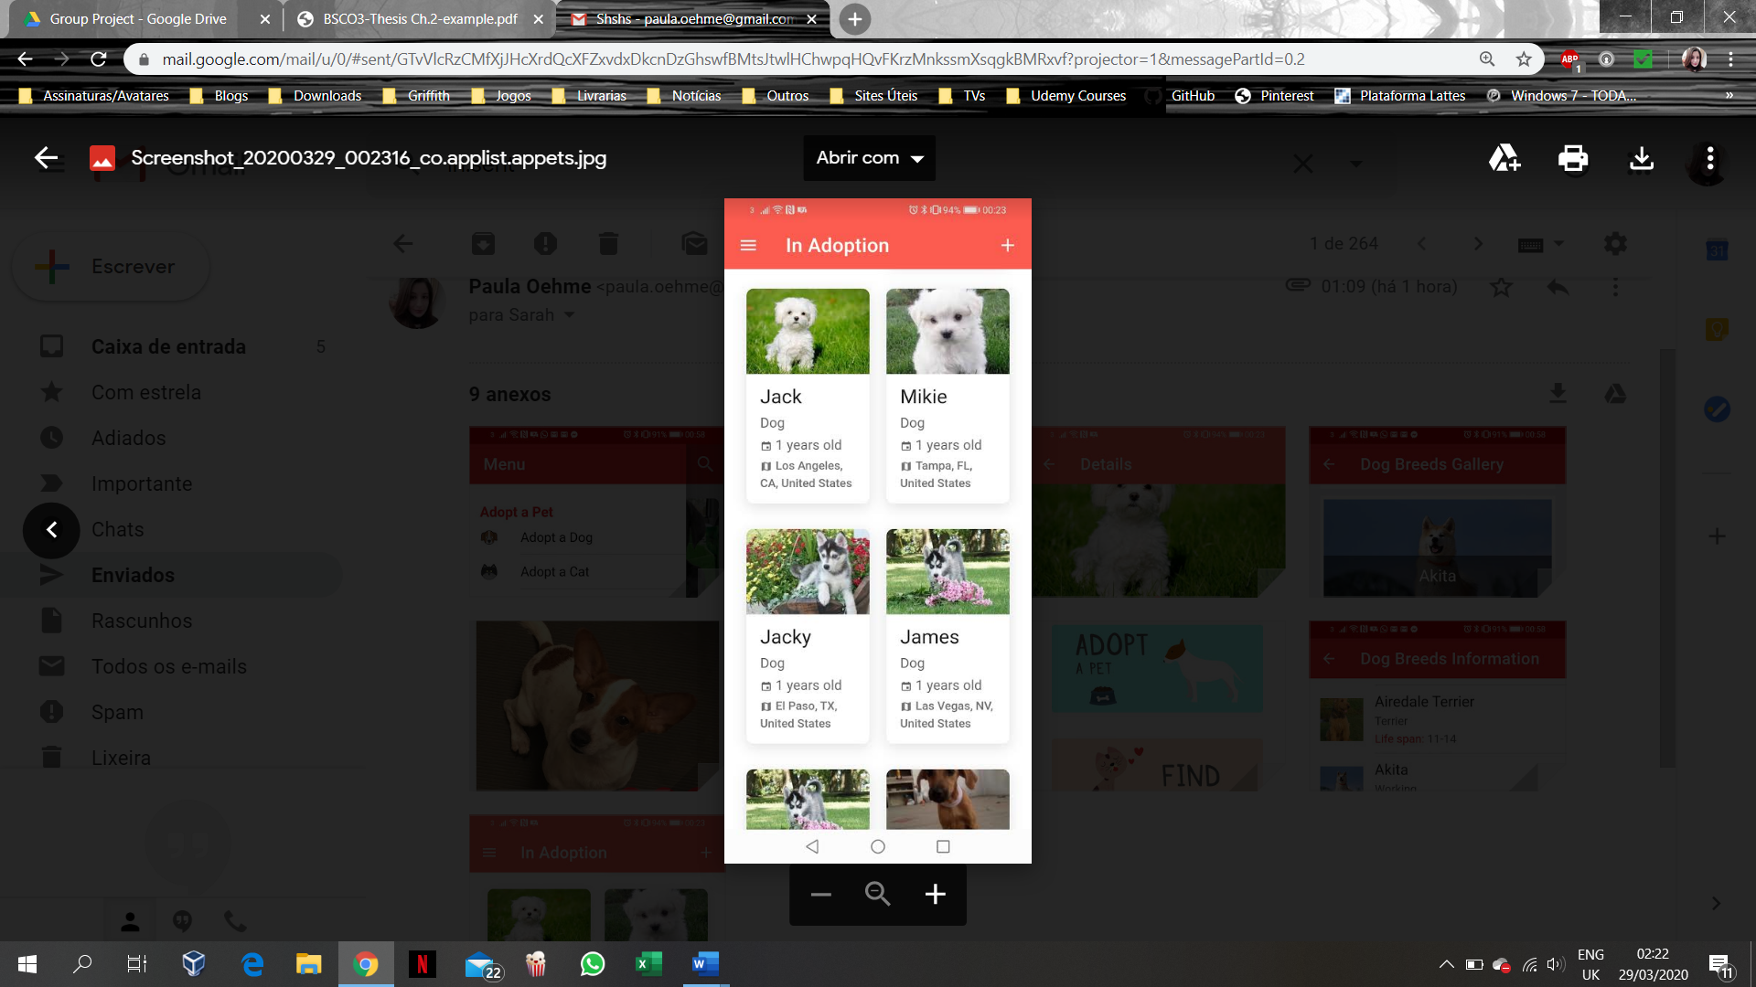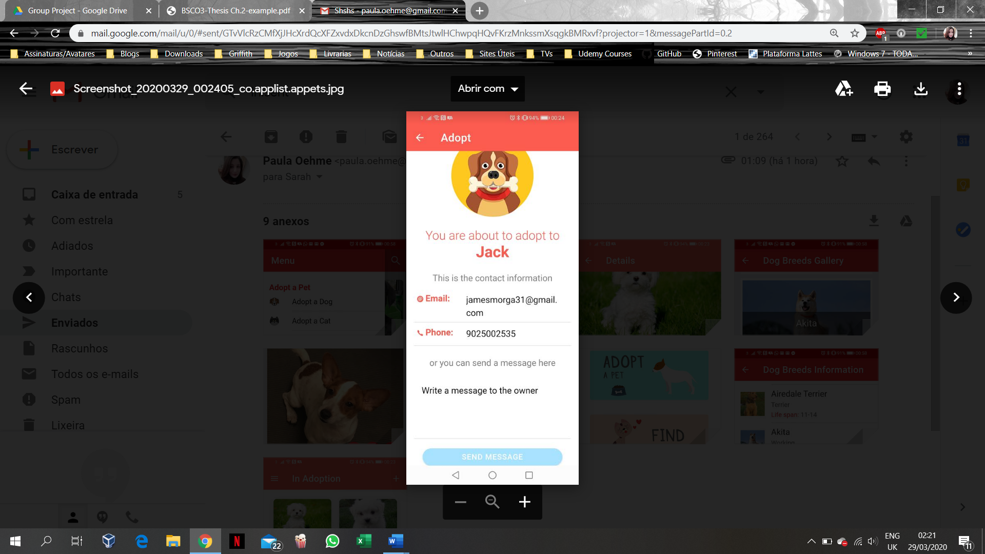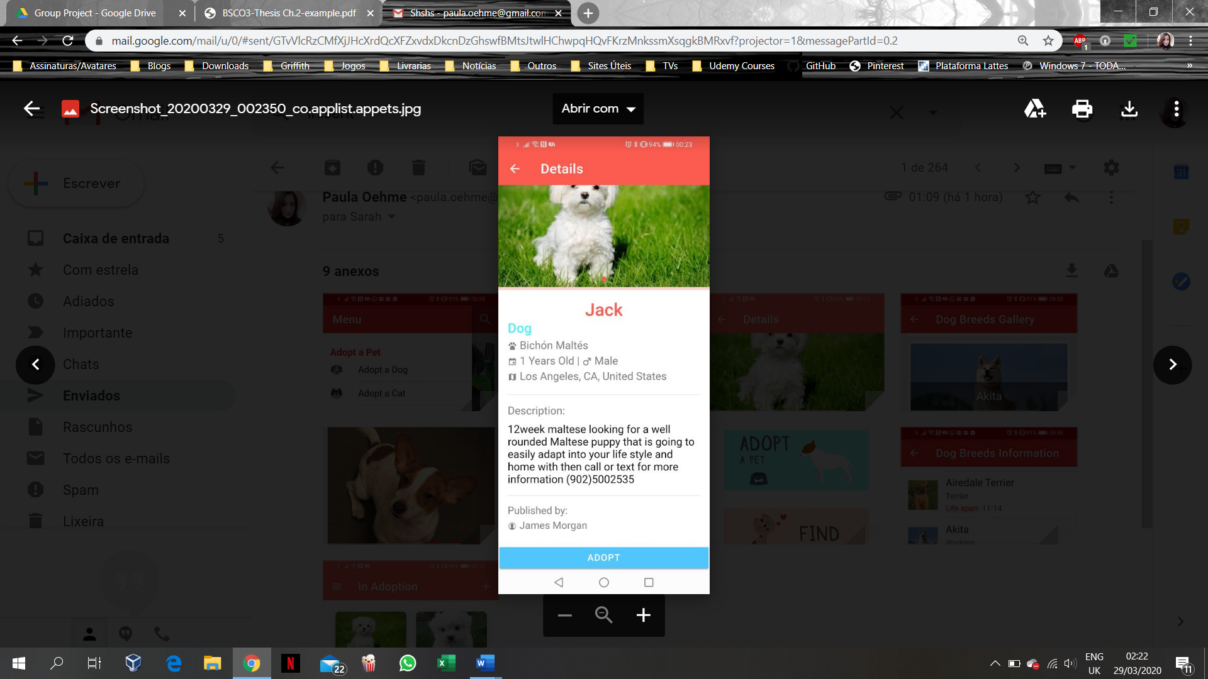

Figure 2.9: Appets app’s Features (Google Play, 2020d).

* **Pets Adoption**

The *Pets Adoption* app provides a search through a database of pets with different categories, such as Dogs, Cats, Rabbits, Horses and Birds. The interesting thing about this app is that it has a database with information and gallery of several dog breeds, such as Akita, Australian Shepherd, among others (please, see Figure 2.9). The application allows you to search for pets, based on their location, breed, age, size, and gender. It provides details about each pet, as well as information about the current owner of the pet. Also, the app allows you to contact the organization/owner of the pet, in order to start the adoption process. The app has a rating of 3.4 from 57 evaluations on Google Play Store (Google Play, 2020e). However, when using the app to find pets in Limerick, Ireland, it did not return any result.

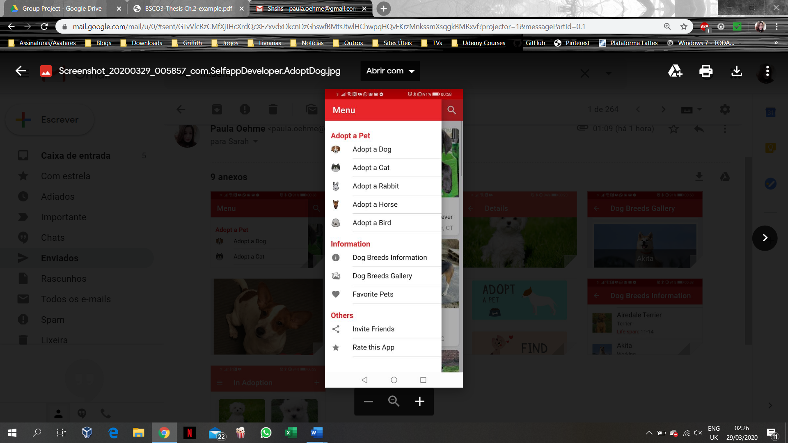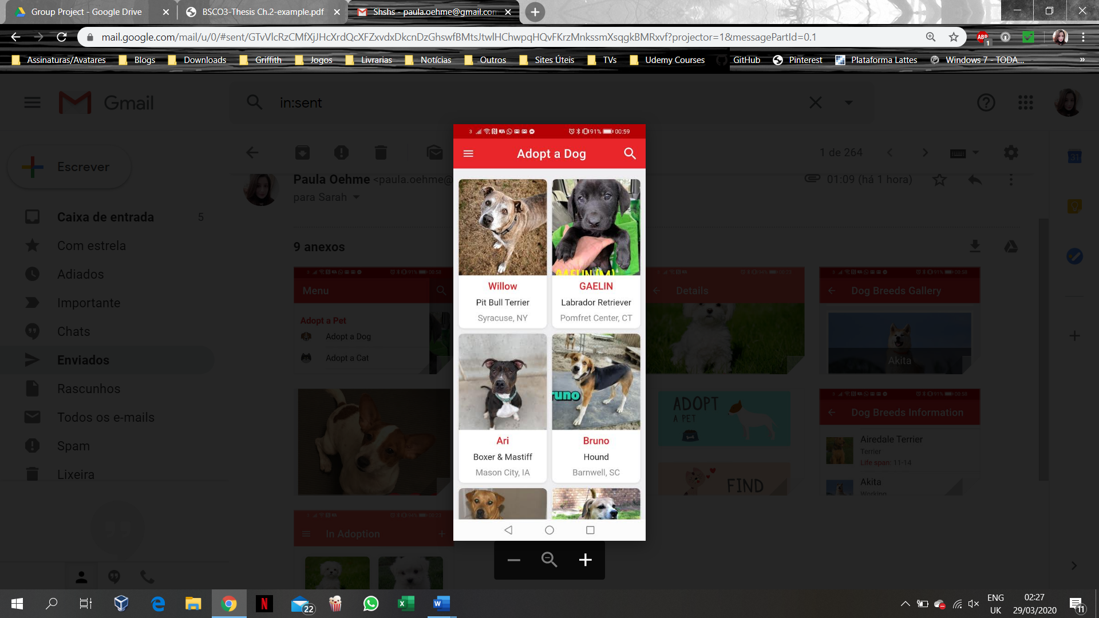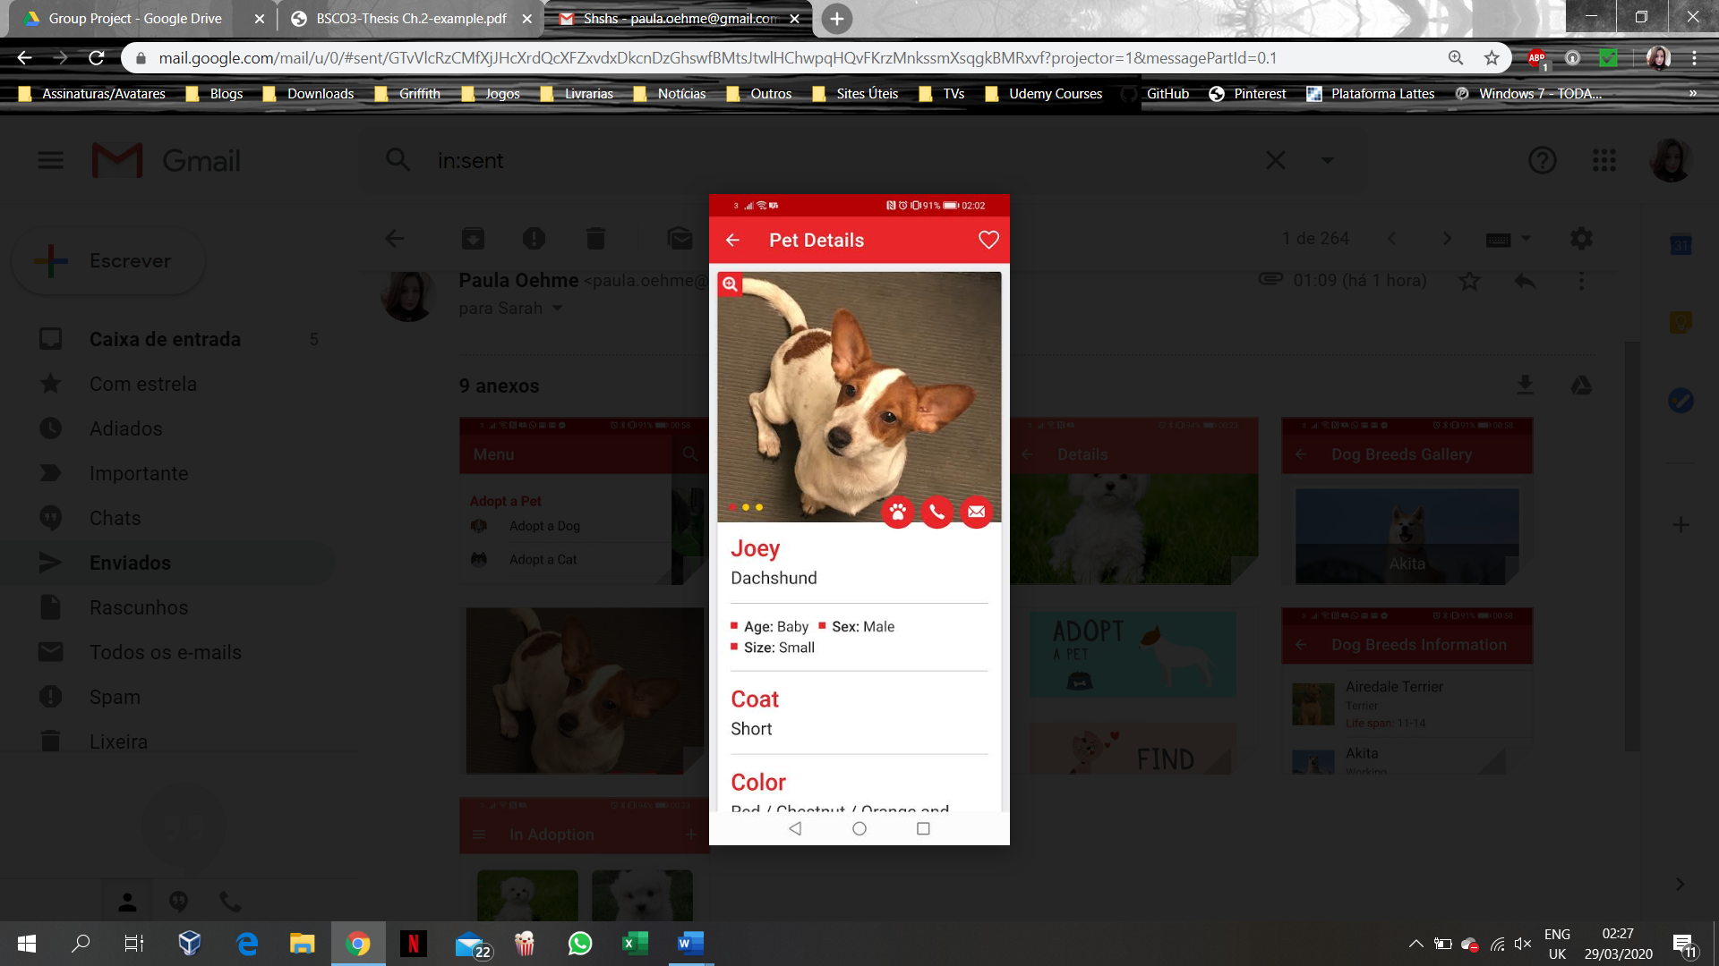

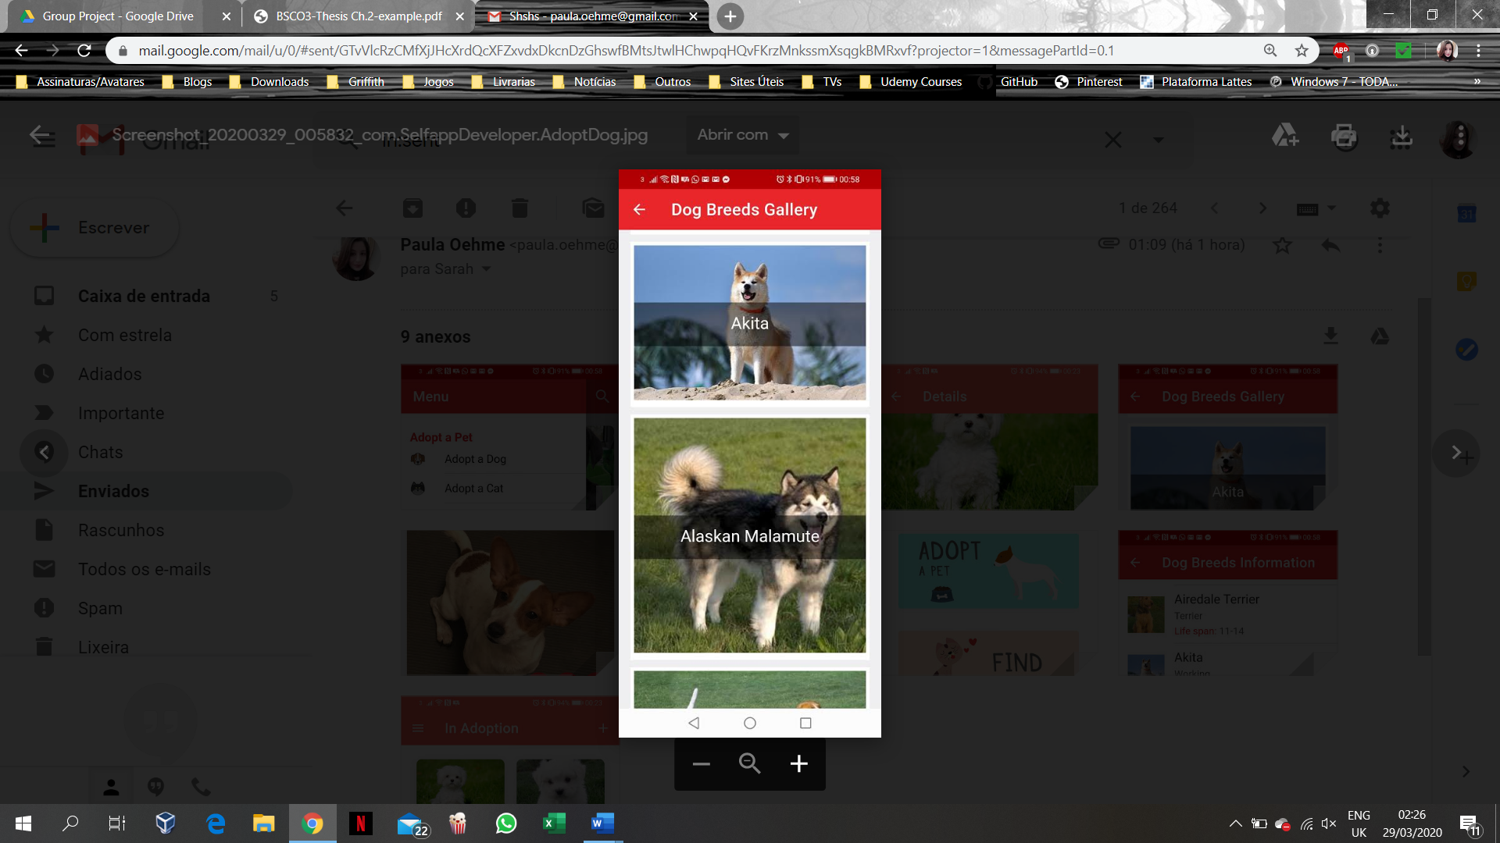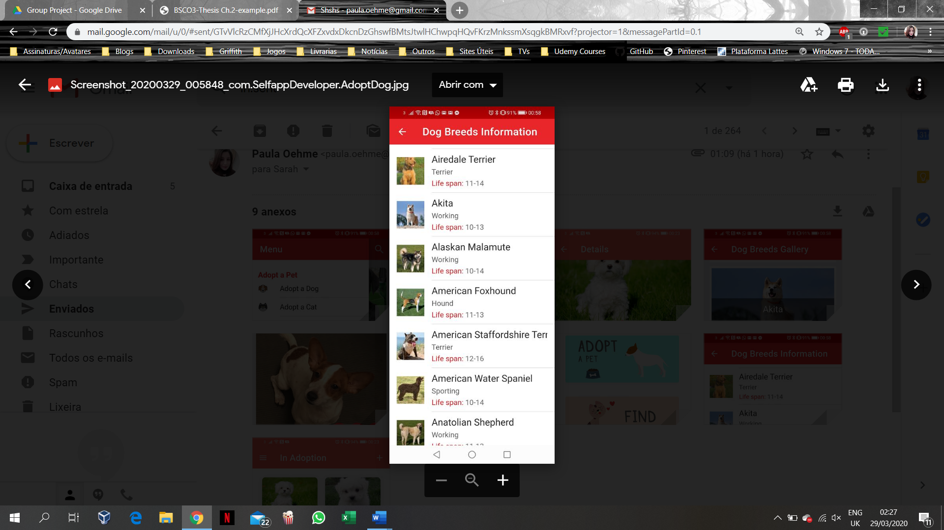

Figure 2.10: Pets Adoption app’s Features (Google Play, 2020e).

## 2.9 Chapter Summary

All the apps discussed in the chapter showed lack of available mobile application for helping potential adopters to find desired pet for adoption locally in Ireland. Unfortunately, we could not find such app for the country, which increases the need of creating such an app, that could as well interface IoT device, like *Google Home*, since nowadays everything is connected to the Internet and everyone is using mobile phones. However, a few apps were found worldwide, providing similar ideas to the current application project.

Even though there are some similarities to those, cited in the discussed Case Studies, the current project aims to provide a more strict range of search for example a country and specially a more reliable source of information regarding the pets, since this information will be provided by registered organizations within the local authorities. Also, the current project aims to provide the means to initiate an adoption process within the shelter without excluding a physical visiting and approval from the organization in question.

The next chapter will describe the project application Analysis phase, the chosen Development methodology and approach to be implemented for the project.

# REFERENCES

Amazon, 2020. *Amazon.* [Online]   
Available at: https://us.amazon.com/Raspberry-Pi-Zero-W-Kit/dp/B07RXHJW9W  
[Accessed 28 March 2020].

Animal Health and Welfare Act, 2013. *Eletronic Irish Statute Book.* [Online]   
Available at: http://www.irishstatutebook.ie/eli/2013/act/15/enacted/en/pdf  
[Accessed 25 March 2020].

Bravo, E., 2019. *Smart.city_lab.* [Online]   
Available at: https://www.smartcitylab.com/blog/urban-environment/amsterdam-launches-a-modular-urban-lighting-system/  
[Accessed 26 March 2020].

Callaham, J., 2017. *Android Authority.* [Online]   
Available at: https://www.androidauthority.com/android-market-google-play-history-754989/  
[Accessed 22 March 2020].

Canney, S., 2019. *Houses of the Oireachtas.* [Online]   
Available at: https://www.oireachtas.ie/en/debates/question/2019-01-22/604/#pq-answers-604  
[Accessed 24 March 2020].

Cherednichenko, S., 2018. *Mobindustry.* [Online]   
Available at: https://www.mobindustry.net/how-to-develop-an-app-for-the-internet-of-things-iot/  
[Accessed 27 March 2020].

Citizens Information, 2019. *Data Protection Act.* [Online]   
Available at: https://www.citizensinformation.ie/en/government_in_ireland/national_government/standards_and_accountability/data_protection.html  
[Accessed 26 March 2020].

Citizens Information, 2020. *Control of Dogs.* [Online]   
Available at: https://www.citizensinformation.ie/en/environment/animal_welfare_and_control/control_of_dogs.html  
[Accessed 26 March 2020].

Control of Dogs Act, 1986. *Eletronic Irish Statute Book.* [Online]   
Available at: http://www.irishstatutebook.ie/eli/1986/act/32/enacted/en/print.html  
[Accessed 24 March 2020].

Council of Europe, 1981. *Conventions.* [Online]   
Available at: https://www.coe.int/en/web/conventions/full-list/-/conventions/treaty/108  
[Accessed 26 March 2020].

Cyrenne, S., 2019. *Homeo Animal.* [Online]   
Available at: https://www.homeoanimal.com/blogs/blog-pet-health/81114180-animal-rescue-and-animal-shelter-what-is-the-difference  
[Accessed 23 March 2020].

Data Protection Act, 1988. *Eletronic Irish Statute Book.* [Online]   
Available at: http://www.irishstatutebook.ie/eli/1988/act/25/enacted/en/print.html  
[Accessed 26 March 2020].

Dataplicity, 2019. *Get Pi connected to the Internet.* [Online]   
Available at: https://docs.dataplicity.com/docs/get-pi-connected-to-the-internet  
[Accessed 24 April 2020].

Dundalk Dog Rescue, 2020. *Dundalk Dog Rescue.* [Online]   
Available at: http://www.dundalkdogrescue.ie/about/  
[Accessed 21 March 2020].

Evans, D., 2011. *Cisco.* [Online]   
Available at: https://www.cisco.com/c/dam/en_us/about/ac79/docs/innov/IoT_IBSG_0411FINAL.pdf  
[Accessed 27 March 2020].

Fromaget, P., 2020. *Raspberry tips.* [Online]   
Available at: https://raspberrytips.com/raspberry-pi-history/  
[Accessed 25 March 2019].

Gebhart, A., 2019. *Cnet.* [Online]   
Available at: https://www.cnet.com/how-to/everything-you-need-to-know-about-google-home/  
[Accessed 28 March 2020].

Google Play, 2020a. *Nest.* [Online]   
Available at: https://play.google.com/store/apps/details?id=com.nest.android  
[Accessed 27 March 2020].

Google Play, 2020b. *Wistle.* [Online]   
Available at: https://play.google.com/store/apps/details?id=com.whistle.bolt  
[Accessed 27 March 2020].

Google Play, 2020c. *Smart Life.* [Online]   
Available at: https://play.google.com/store/apps/details?id=com.tuya.smartlife&gl=IE  
[Accessed 27 March 2020].

Google Play, 2020d. *Appets.* [Online]   
Available at: https://play.google.com/store/apps/details?id=co.applist.appets&gl=IE  
[Accessed 2 March 2020].

Google Play, 2020e. *Pets Adoption.* [Online]

Available at: https://play.google.com/store/apps/details?id=com.SelfappDeveloper.AdoptDog&gl=IE  
[Accessed 3 March 2020].

Hardwood, T., 2019. *Postscapes.* [Online]   
Available at: https://www.postscapes.com/iot-history/  
[Accessed 26 March 2020].

Horwitz, L., 2017. *Cisco.* [Online]   
Available at: https://www.cisco.com/c/en/us/solutions/internet-of-things/smart-city-infrastructure.html  
[Accessed 27 March 2020].

JetRuby, 2017. *Medium.* [Online]   
Available at: https://expertise.jetruby.com/brief-history-of-mobile-apps-286fbbf766a9  
[Accessed 21 March 2020].

Johnson, B., 2020. *Howstuffworks.* [Online]   
Available at: https://computer.howstuffworks.com/raspberry-pi2.htm  
[Accessed 24 April 2020].

Lee, W.-M. & Chng, C., 2018. *Code magazine.* [Online]   
Available at: https://www.codemag.com/Article/1607071/Introduction-to-IoT-Using-the-Raspberry-Pi  
[Accessed 27 March 2020].

Lueth, K. L., 2018. *Iot analytics.* [Online]   
Available at: https://iot-analytics.com/state-of-the-iot-update-q1-q2-2018-number-of-iot-devices-now-7b/  
[Accessed 28 March 2020].

Mitchel, S., Villa, N., Stewart-weeks, M. & Lange, A., 2013. *Cisco.* [Online]   
Available at: https://www.cisco.com/c/dam/en_us/solutions/industries/docs/gov/everything-for-cities.pdf  
[Accessed 28 March 2020].

Pet Rescue, 2019. *Pet Rescue.* [Online]   
Available at: https://www.petrescue.com.au/library/articles/the-difference-between-a-pound-shelter-and-rescue  
[Accessed 23 March 2020].

PETA - People for Ethical Treatment of Animals, n.d. *PETA - People for Ethical Treatment of Animals.* [Online]   
Available at: https://www.peta.org/issues/animal-companion-issues/animal-shelters/  
[Accessed 23 March 2020].

Pounds Provision and Maintenance Act, 1935. *Eletronic Irish Statute Book.* [Online]   
Available at: http://www.irishstatutebook.ie/eli/1935/act/17/enacted/en/print.html  
[Accessed 22 March 2020].

Protection of Animals Amendment Act, 1965. *Eletronic Irish Statute Book.* [Online]   
Available at: http://www.irishstatutebook.ie/eli/1965/act/10/enacted/en/print  
[Accessed 23 March 2020].

Raspberry Pi Foundation, 2020. *Raspberrypi.* [Online]   
Available at: https://www.raspberrypi.org/documentation/usage/gpio/  
[Accessed 24 April 2020].

Rescue Animals Ireland, 2020a. *Rescue Animals Ireland.* [Online]   
Available at: http://rescueanimalsireland.ie/all-rescues  
[Accessed 23 March 2020].

Rescue Animals Ireland, 2020b. *Rescue Animals Ireland.* [Online]   
Available at: http://rescueanimalsireland.ie/useful-information/adopting-a-dog  
[Accessed 26 March 2020].

Romkey, J., Hackett, S., Stanford-Clark, A. & Nipper, A., 2014. A Brief History of the Internet of Things.. *Baseline*, 9 September, p. 1. Available at: http://web.b.ebscohost.com/ehost/detail/detail?vid=0&sid=6626a862-e4f9-44ec-bbef-55b1c08d6ade%40pdc-v-sessmgr04&bdata=JnNpdGU9ZWhvc3QtbGl2ZQ%3d%3d#AN=98969708&db=buh

[Accessed 27 March 2020].

The Dublin Society for Prevention of Cruelty ti Animals - DSPCA, 2020. *The Dublin Society for Prevention of Cruelty ti Animals - DSPCA.* [Online]   
Available at: https://www.dspca.ie/dogadoptionprocess/  
[Accessed 25 March 2020].

Upton, L., 2013. *Raspberry Pi Blog.* [Online]   
Available at: https://www.raspberrypi.org/blog/zoological-society-of-london-saving-rhinos-with-the-pi/  
[Accessed 28 March 2020].

Viswanathan, P., 2019. *Lifewire.* [Online]   
Available at: https://www.lifewire.com/what-is-a-mobile-application-2373354  
[Accessed 23 March 2020].

Westernberg, J., 2019. *Android authority.* [Online]   
Available at: https://www.androidauthority.com/google-home-services-749968/  
[Accessed 28 March 2020].

# Appendix A4

|  |  |
| --- | --- |
| **County** | **Shelter / Rescue / Pound name** |
|  |  |
| Clare |  |
|  | An Cat Dubh Sanctuary |
|  | Burren Animal Rescue |
|  | Clare Animal Welfare |
|  | Clare Dog Pound |
|  | Clare Greyhound Project |
|  | Clare Society for Prevention of Cruelty to Animals (Clare SPCA) |
|  | Homeward Bound |
|  | Martina's Babydog Rescue |
|  | Rover Rescue |
|  | The hogsprickle - Helping Hedgehogs |
|  |  |
| Cork |  |
|  | Animal Advocacy |
|  | Animal Care Society |
|  | Cork Cat Action Trust |
|  | Cork City Dog Pound |
|  | Cork County Dog Pound |
|  | Cork Society for Prevention of Cruelty to Animals (CSPCA) |
|  | Dog Action Welfare Group (DAWG) |
|  | Glansillagh Animal Rescue Centre |
|  | H.A.R.T |
|  | Pauline’s Rescue |
|  | RAWR (Rural Animal Welfare Resources) |
|  | The Donkey Sanctuary |
|  |  |
| Dublin |  |
|  | A Dog's Life |
|  | ARAN |
|  | Ashton Pound |
|  | Blue Cross Ireland |
|  | Cat and Dogs Protection Association of Ireland |
|  | Cats Aid |
|  | Cats Friends Rescue |
|  | Clondalkin Animal Aid |
|  | Dog Rescue Ireland (Greyhounds) |
|  | Dogs Aid |
|  | Dogs Angels Ireland |
|  | Dogs in Distress |
|  | Dogs Trust |
|  | Dublin Society for Prevention of Cruelty to Animals (DSPCA) |
|  | Dublin Small Animal Rescue |
|  | Glencarraig Dog Rescue |
|  | Last Chance Animals |
|  | My Lovely Horse Rescue |
|  | North Dublin Cat Rescue |
|  | North Dublin SPCA |
|  |  |
| Galway |  |
|  | Galway Cat Rescue |
|  | Galway County Dog Pound |
|  | Galway Society for Prevention of Cruelty to Animals (Galway SPCA) |
|  | Irish Pound Dogs |
|  | MADRA - Mutts Anonymous Dog Rescue and Adoption |
|  | Renvyle Cat and Dog Rescue |
|  | Whiskers New Park Animal Sanctuary |
|  |  |
| Kerry |  |
|  | Animal Help Net |
|  | HUG Homes for unwanted Greyhounds |
|  | Kerry Dog Pound |
|  | Kerry Society for Prevention of Cruelty to Animals (Kerry SPCA) |
|  | Kingdom Cat and Dog Rescue (KCADR) |
|  | KLAWS |
|  |  |
| Kildare |  |
|  | Celtic Animal Life Line |
|  | Kildare and West Wicklow Society for Prevention of Cruelty to Animals (KWWSPCA) |
|  | Kildare Animal Foundation |
|  | Kildare Dog Pound |
|  | The Rat Retreat Ireland |
|  |  |
| Kilkenny |  |
|  | Carlow Kilkenny Dog Pound |
|  | Inistioge Puppy Rescue |
|  | Kilkenny Society for Prevention of Cruelty to Animals (Kilkenny SPCA) |
|  |  |
| Laois |  |
|  | Cara Dog Rescue |
|  | Laois Dog Pound |
|  | Laois Society for Prevention of Cruelty to Animals (Laois SPCA) |
|  |  |
| Leitrim |  |
|  | Leitrim Animal Welfare |
|  | Leitrim Dog Pound |
|  | Leitrim Society for Prevention of Cruelty to Animals (Leitrim SPCA) |
|  |  |
| Limerick |  |
|  | Limerick Animal Welfare |
|  | Limerick City and County Dog Shelter |
|  | Limerick Society for Prevention of Cruelty to Animals (Limerick SPCA) |
|  |  |
| Longford |  |
|  | Hungry Horse Outside |
|  | Irish Society for Prevention of Cruelty to Animals (ISPCA) |
|  | Longford Dog Pound |
|  | Longford Society for Prevention of Cruelty to Animals (Longford SPCA) |
|  |  |
| Louth |  |
|  | Collon Animal Sanctuary |
|  | Drogheda Animal Rescue |
|  | Dundalk Dog Rescue |
|  | Louth Dog Pound |
|  | Louth Society for Prevention of Cruelty to Animals (Louth SPCA) |
|  | Westie Rescue |
|  |  |
| Mayo |  |
|  | Ainmhithe Animal Rescue |
|  | Horse and Donkey Mayo Sanctuary |
|  | Mayo Dog Pound |
|  | Mayo Society for Prevention of Cruelty to Animals (Mayo SPCA) |
|  | North West Society for Prevention of Cruelty to Animals (NWSPCA) |
|  |  |
| Meath |  |
|  | Dog Rescue Coolronan |
|  | Eden Farmed Animal Sanctuary |
|  | Last Hope Animals |
|  | Meath Dog Pound |
|  | National Exotic Animal Sanctuary |
|  | Royal Dog Rescue |
|  |  |
| Offaly |  |
|  | Offaly Dog Pound |
|  | Offaly Society for Prevention of Cruelty to Animals (OSPCA) |
|  | Orchard Greyhound Sanctuary Ireland |
|  |  |
| Roscommon |  |
|  | Athlone & West Midlands Society for Prevention of Cruelty to Animals (Athlone & West Midlands SPCA) |
|  | Glen Of Imaal Terrier Rescue Ireland |
|  | Heart of Ireland Animal Rescue & Rehabilitation |
|  | Roscommon Dog Pound |
|  | Roscommon Society for Prevention of Cruelty to Animals (Roscommon SPCA) |
|  |  |
| Sligo |  |
|  | Sathya Sai Sanctuary Trust for Nature |
|  | Sligo Dog Shelter |
|  |  |
| Tipperary |  |
|  | Cottage Rescue |
|  | Mo Chara Animal Rescue |
|  | PAWS |
|  | Tipperary Dog Pound |
|  |  |
| Waterford |  |
|  | Deise Animal Sanctuary |
|  | Rosóg Equine Rescue |
|  | Waterford Dog Shelter |
|  |  |
| Westmeath |  |
|  | Moate & Midlands Dog Rescue |
|  | Shirley's Abandoned Cat and Dog Rescue |
|  | Westmeath Dog Pound |
|  |  |
| Wexford |  |
|  | Halfway Hen House |
|  | Irish Wildlife Sanctuary |
|  | Network Dog Rescue |
|  | New Ross Society for Prevention of Cruelty to Animals (New Ross SPCA) |
|  | North Wexford Society for Prevention of Cruelty to Animals (North Wexford SPCA) |
|  | Seal Rescue Ireland |
|  | South East Animal Rescue |
|  | Wexford Dog Pound |
|  | Wexford Society for Prevention of Cruelty to Animals (Wexford SPCA) |
|  |  |
| Wicklow |  |
|  | Ash Animal Rescue |
|  | Aughrim Cat Rescue |
|  | Greystones Kitty Hostel Rescue & TNR |
|  | IHWT Equine Welfare Centre |
|  | Wicklow Animal Welfare |
|  | Wicklow Dog Pound |
|  | Wicklow Society for Prevention of Cruelty to Animals (Wicklow SPCA) |